1. In the previous section, we talked about **Java-Based** **Configuration**.
   1. @Component.
   2. @Bean.
2. **Agenda**:
   1. In this section, we will talk about **Annotation-Based Configuration.**
3. In annotation based configuration, we ask Spring IoC Container to create and inject dependencies through just annotations without writing any java code unlike we did when java-based configuration through @Configuration and @Bean on method.
4. 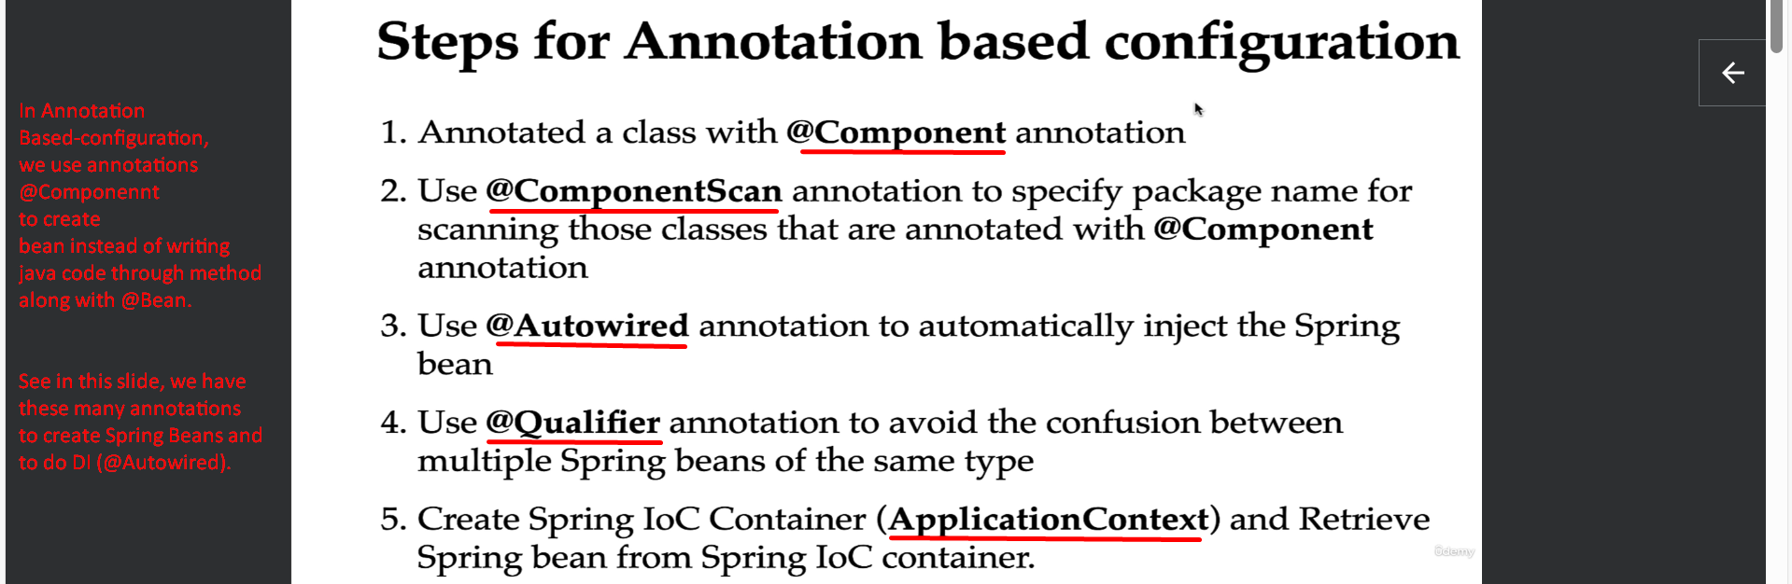
5. 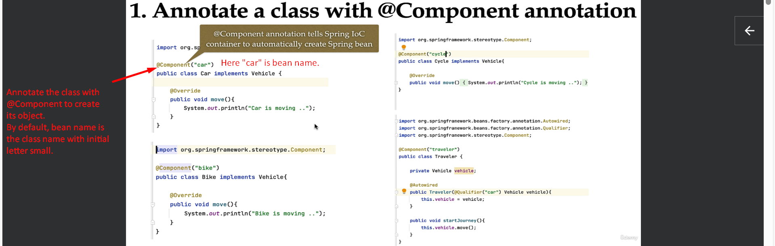
6. @ComponentScan  
   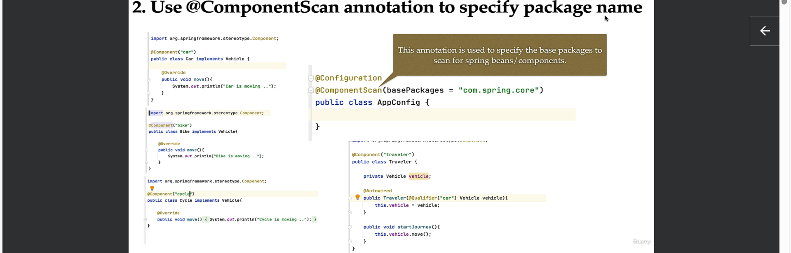
7. 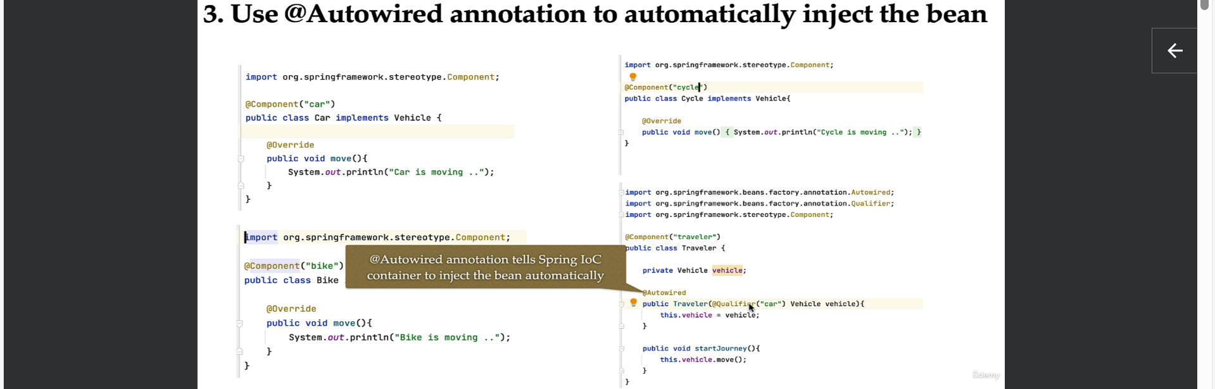
8. 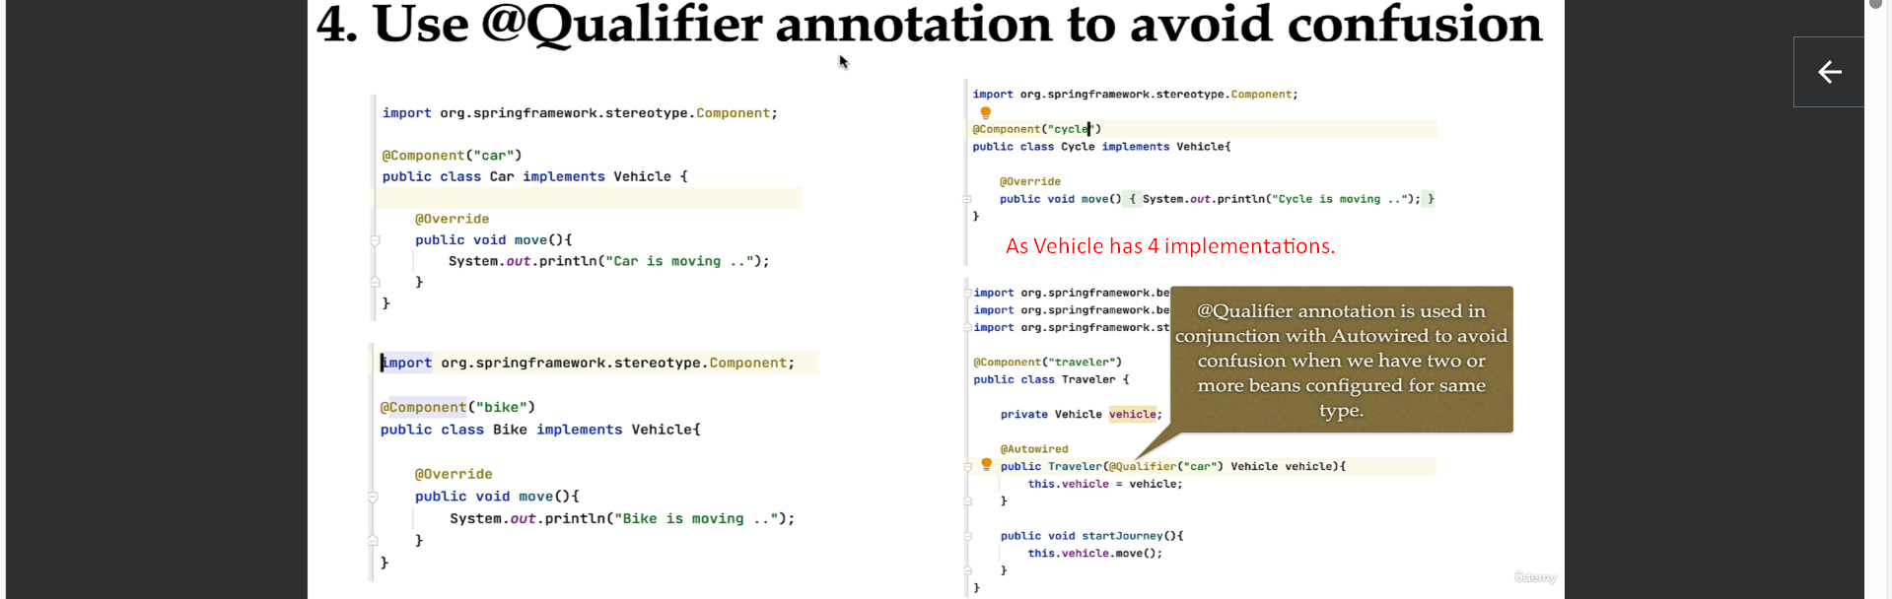
9. 